4 DAILY WINS TO WIN THE DAY
Maxwell-Inspired
Small disciplines, done daily, create big results.
Success starts with winning the morning. Prime your body, mind, heart, and soul with four quick wins—15 minutes or less.

1. Physical Win – Activate Your Body
Move for 1+ minute to signal go-time.
Pushups, jumping jacks, stretching, brisk movement.
2. Mental Win – Feed Your Mind
Spend 5+ minutes learning.
Read, audiobook, training, or development content.
3. Emotional Win – Fill Your Heart
Connect for 3+ minutes.
Text, call, or express appreciation to someone you care about.
4. Spiritual Win – Center Your Soul
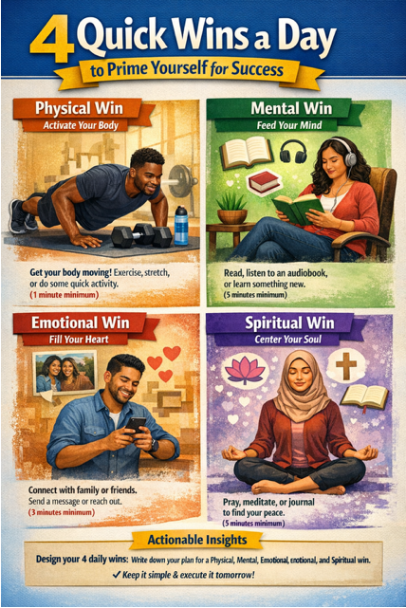
Ground yourself for 5+ minutes.
Breathing, meditation, prayer, or journaling.

Your Challenge
- Write down your 4 Wins
- Keep them simple
- Execute tomorrow morning
Start small. Be consistent.
Win the morning → Win the day.

